Programme designed by

George Steele

Rochdale Gramophone Society

A taste of Tchaikovsky

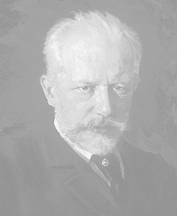

A programme by

George Steele

18 March 2011

Peter Ilyich Tchaikovsky (1840 – 1873)

“Tchaikovsky could claim to be the world’s most popular classical composer. His music has always held a special appeal, for its passion, lyricism, extravagant emotionalism and glowing orchestral colour. It reflects the extremes of temperament of its composer – a moody melancholy character, prone to fits of depression but also of heightened optimism.”
Romantic Composers by Wendy Thompson

This ‘taste’ of Tchaikovsky seeks to illustrate the above quotation.

A taste of Tchaikovsky

Rose Adagio from Sleeping Beauty | London Symphony Orchestra  Anatole Fistoulari
String Quartet No 1 Movt 2 | Endellion String Quartet
Symphony No 2 Movt 3 | Wiener Philharmoniker  Claudio Abbado
Piano Concerto No 1 Movt 3 | Barry Douglas (piano)  London Symphony Orchestra  Leonard Slatkin
String Quartet No 2 Movt 4 | Endellion String Quartet
Swan Lake Scene 1  Finale | Orchestra of the Royal Opera House, Covent Garden
Violin Concerto Movt 2 | Mariko Honda (violin)  Slovak Philharmonic  Keith Clark
Interval

Serenade for Strings Movt 1 & 2 | Philharmonia Slavonica  Alfred Scholz
1812 overture | London Symphony Orchestra  Yuri Ahronovitch
Symphony No 6 Movt 4 | Berliner Philharmoniker  Herbert von Karajan

